User manual: Oracle ERP system in recruitment

Made by: Dina Elsayed Elsayed

Yasmine Ahmed Saeed

Amira Mostafa Abd-Elrazik

Felopater Maged Fawz

Esraa Farid Shawky

Introduction

This user manual aims to explain the process of using Oracle ERP system to manage the recruiting process.

In this case we have our company Fly High airlines that is having difficulties managing the number of applicants and recording their data.

With using Oracle ERP system, we aim to facilitate the managing of data of the applicants and integrate them when they are part of the company

What motivated us to do this is because people are the most important part of any organization, and we want to facilitate the on boarding process as much as possible for the Human resources department.

System requirements:

* Gaining access to the server of Oracle or purchasing a license to use the application on the company devices
* To get the program running we’ll need a laptop with enough capacity or a computer device.
* Strong and staple internet connection
* Java application

Getting started:

After the installation of the program the new users will have their responsibilities assigned to them with user names and passwords that they can change upon logging in for the first time.

After the recruiter logs in they will be able to add new applicants and later change their status to employees or remove their data from the system

The applicant’s data will be provided either from social media advertisement or recruiting applications.

User interface Guide:

After the user logs in using the user's name and the password created, we will first be able to see the interface of the program and the navigator.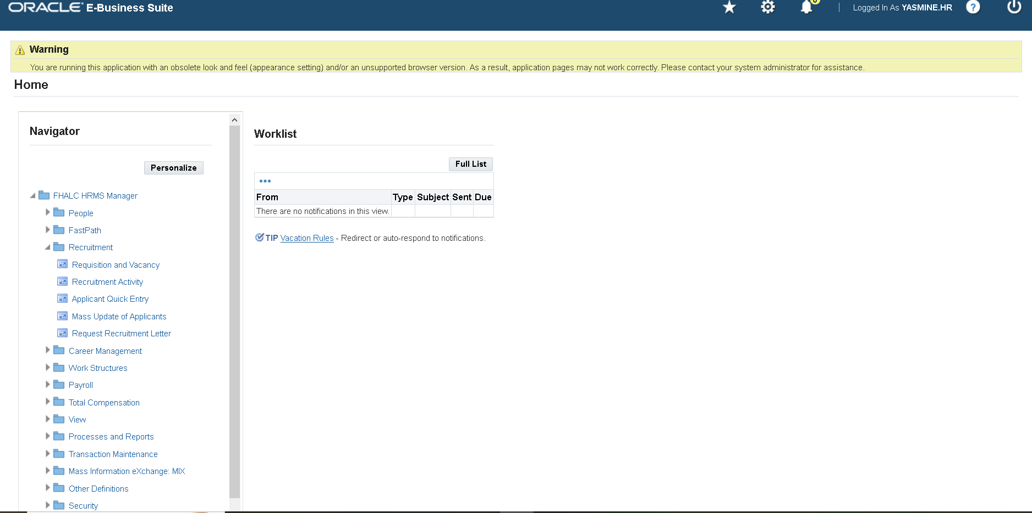

How to perform tasks:

* As we are working in the recruitment, we will choose the Recruitment responsibility from the navigator
* The first step would be sub-responsibility which is the Requisition and vacancy
* Recruitment Step: Job Creation for Finance and Production 2024

During this stage, we focused on identifying and creating critical roles essential for the Finance 2024 and Production 2024 tracks. The key positions established include:

1. Finance Manager

- Responsibilities: Overseeing financial planning and analysis, managing budgets, and ensuring compliance with financial regulations.

- Qualifications: Degree in finance or accounting, extensive experience in financial management, and strong analytical skills.

- Application Process: Submission of resume, cover letter, and references.

2. Accounting Section Head

- Responsibilities: Managing the accounting team, overseeing accounting operations, and ensuring accurate financial reporting.

- Qualifications: Degree in accounting, CPA certification, and senior-level accounting experience.

- Application Process: Candidates should submit a resume, cover letter, and examples of previous work.

3. Supply Chain Manager

- Responsibilities: Coordinating supply chain operations, managing supplier relationships, and optimizing logistics processes.

- Qualifications: Degree in supply chain management or related field, experience in supply chain roles, and strong organizational skills.

- Application Process: Submission of resume, cover letter, and project details handled.

By defining these roles, we ensure that the organizational structure of Finance and Production 2024 aligns with our strategic goals, fostering efficiency and growth

* The second sub-responsibility would be the recruitment activity
* Recruitment activity for several available vacancies at the company
* created 2 recruitment activities from the recruitment function for 3 available vacancies (accounting section head, supply chain manager and finance manager)
* First recruitment activity is a LinkedIn ad. (added activity type, planned and actual cost, start date, end date and deadline date for the ad and designated vacancies)
* Second recruitment activity is a recruitment agency (added activity type, planned and actual cost, start date, end date and deadline date for the agency and designated vacancies).

Define Recruitment Activity:

Enter Activity Name

Enter Dates

Enter Organization

Enter Actual & Planned Costs

Enter Authorized, Internal & Contact Person’s Details

Enter Recruiting For. (Previous Step in Recruitment Cycle)

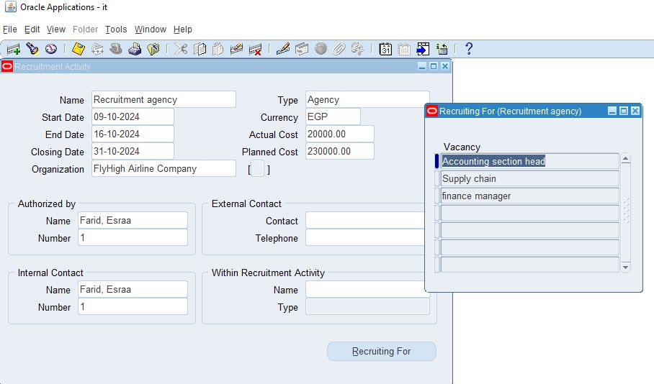

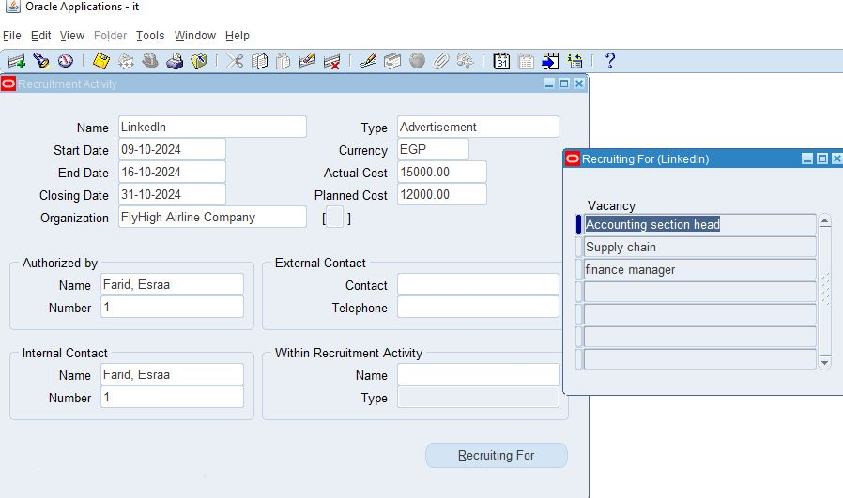

* The third sub-responsibility would be the Applicant quick entry

After receiving the application from the social media platforms and the recruitments applications we will now start recording the data of the applicants on the system

First, we will enter the name and choose a title, the gender is chosen according to the title and then enter the phone number. At this step all people are applicants.

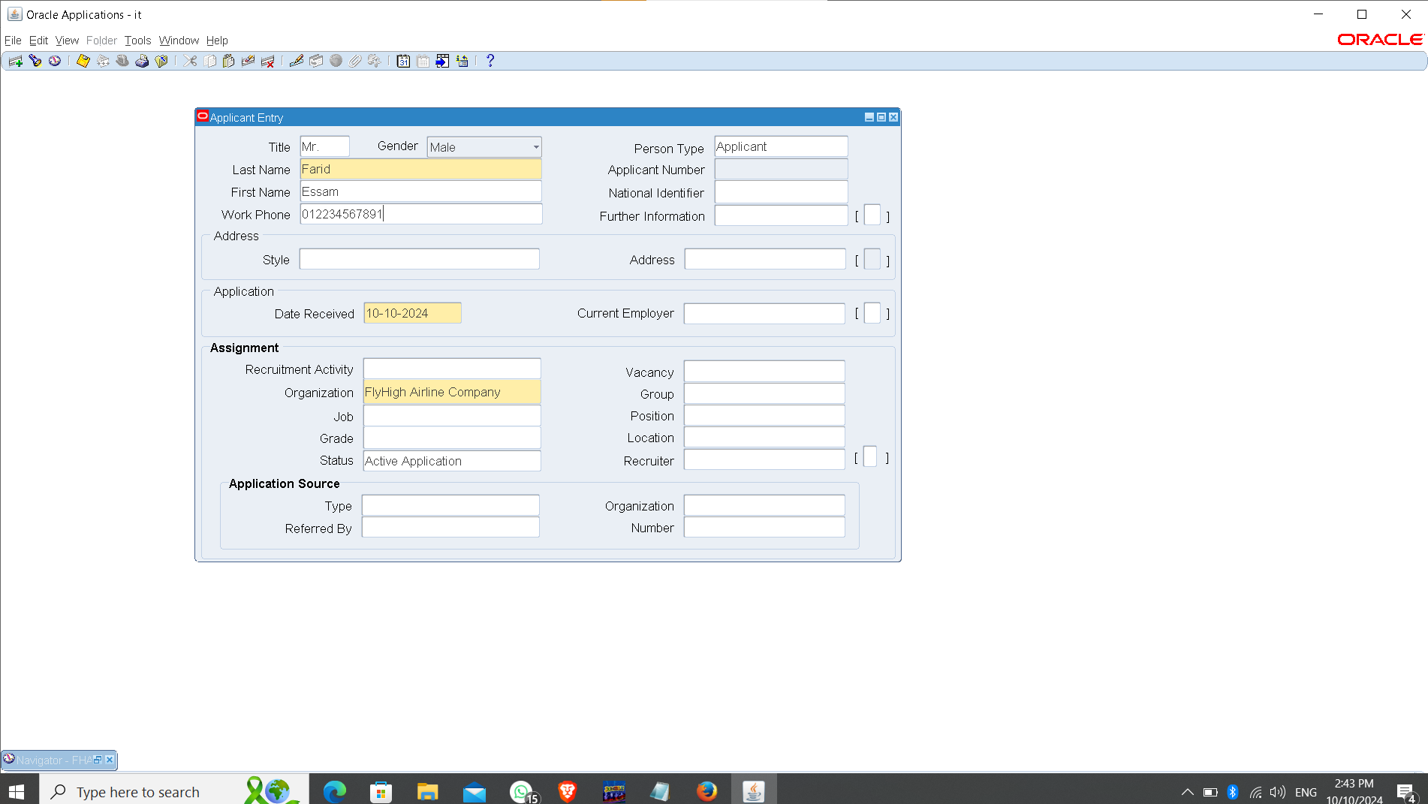

The next step would be to choose the address for each applicant 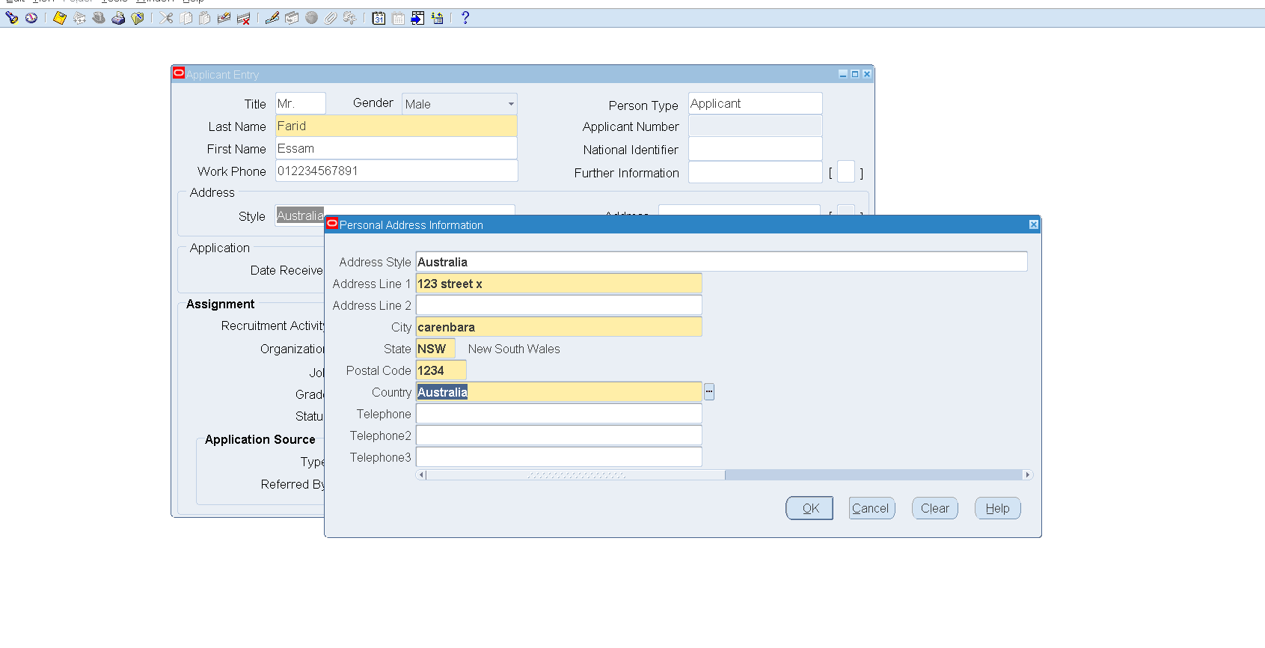

Secondly, we will be entering the application date and the current employer of the applicant

Thirdly, we will start assigning a position and grade to the applicant which were already created in the first Sub-responsibility

We will also assign the source of the applicant which were already created in the second Sub-responsibility

Lastly, we will record the applicant source and the organization if they were through a recruitment agency and then click save and now, we have an applicant recorded and automatically assigned a number.

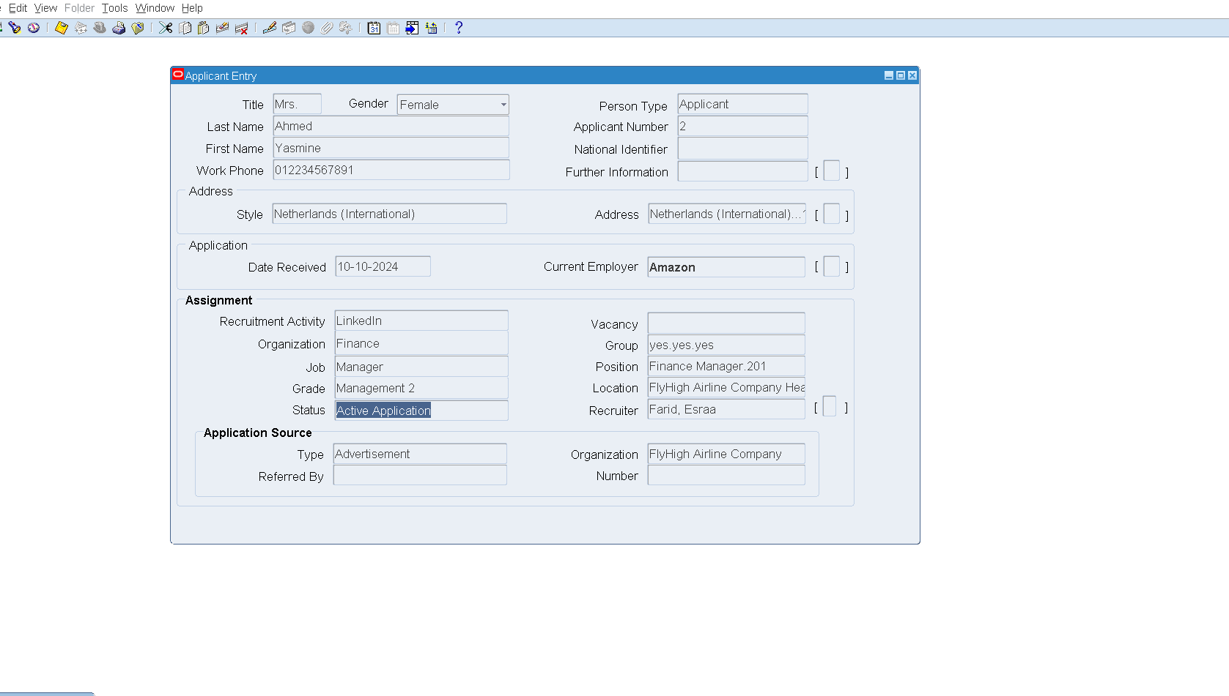

* The fourth and last step of the recruitment process would be to mass update the applicants to employees

Query the screen

And view the applicant’s statuses.

Select One or Select All Applicants

Press The “Update” Button to Update their Statuses & Enter the Recruiter Name

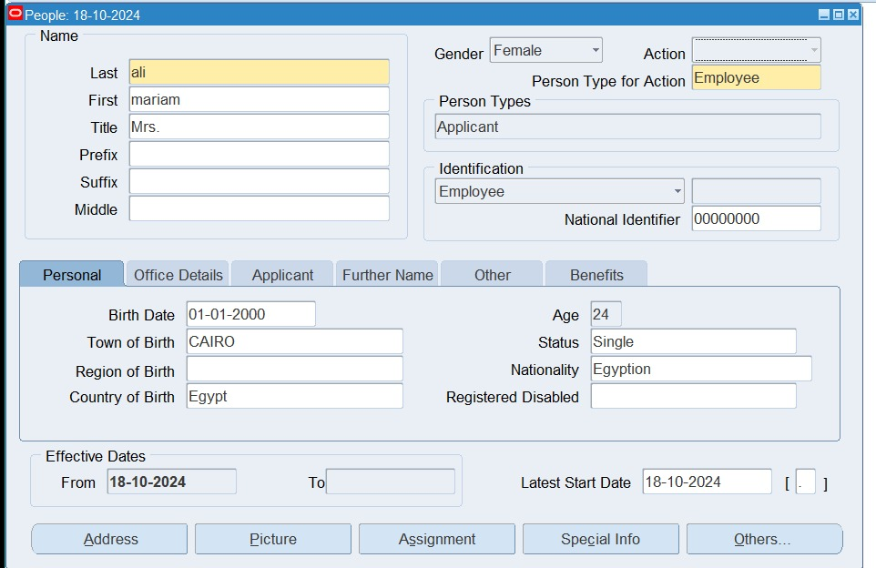

After the mass update we will be able to see the changes and the updates of the applicants on the system whether they were terminated or accepted: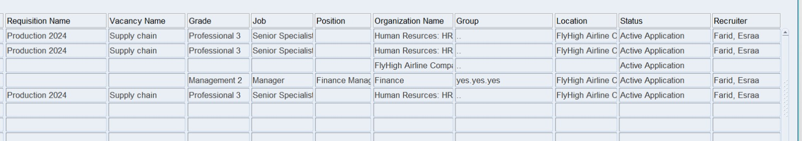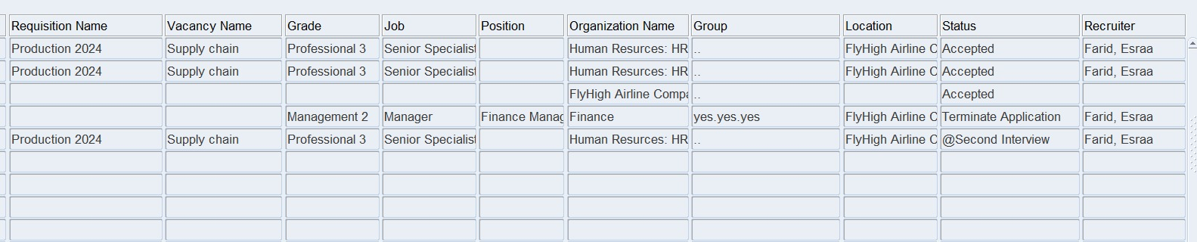

conclusion:

People will always be the backbone of any organization and will either lead to its downfall or its success. That's why the recruitment process is considered one of the most important steps in building any organization.

Digitalizing the process would make much easier and not as time consuming as it usually is. Oracle ERP system is one of many that facilitates the recruitment and allows organizations to store hundreds of millions of data for applicants and employees at the tip of the recruiter’s fingers.

Now after we have showed how the process works; we hope many organizations will be able to make use of the program to build leading organizations.